|  |  |
| --- | --- |
| **CURRICULUM VITAE *of***  **LEIGHTON LYLE MESSINA** | |
| **BSc STudent** | |
| CONTACT**Contact number:**0664661333 **Email address:** [leigthonmessina2@gmail.com](mailto:leigthonmessina2@gmail.com) **Student email:** msslei003@myuct.ac.za | PerSOnaL DeTAILS   Name: Leigthon Lyle  Surname: Messina  Address: 61 Boschoff Way  Westridge  Mitchells Plain  7785  Identity Number: 0309135096084  Date of Birth: 13 September 2003  Gender: Male  Marital Status: Single  Health: Excellent  Disabilities: None  Criminal Record: None  Language: English & Afrikaans  Hobbies: Coding  Working out  Making music |
| SKILLS Computer Literacy  Software Skills  Problem-Solving  Versatility | Education Last School Attended: Mondale High School  Highest Grade Passed: Grade 12  Subjects: English Home Language  Afrikaans First Additional Language  Mathematics  Physical Sciences  Life Sciences  Accounting  Life Orientation    To Complete: Bachelor of Science Majoring in Computer  Science and Computer Engineering  Institution: University of Cape Town  Current year  of Study : 2nd Year |
|  |

# Work Experience

Having been a student for most of my life I currently possess no work experience other than volunteer work

at my church. However, I am very determined and willing to learn, and I look forward to proving myself as an industrious worker if you would give me a chance.

# ADDITIONAL DOCUMENTATION

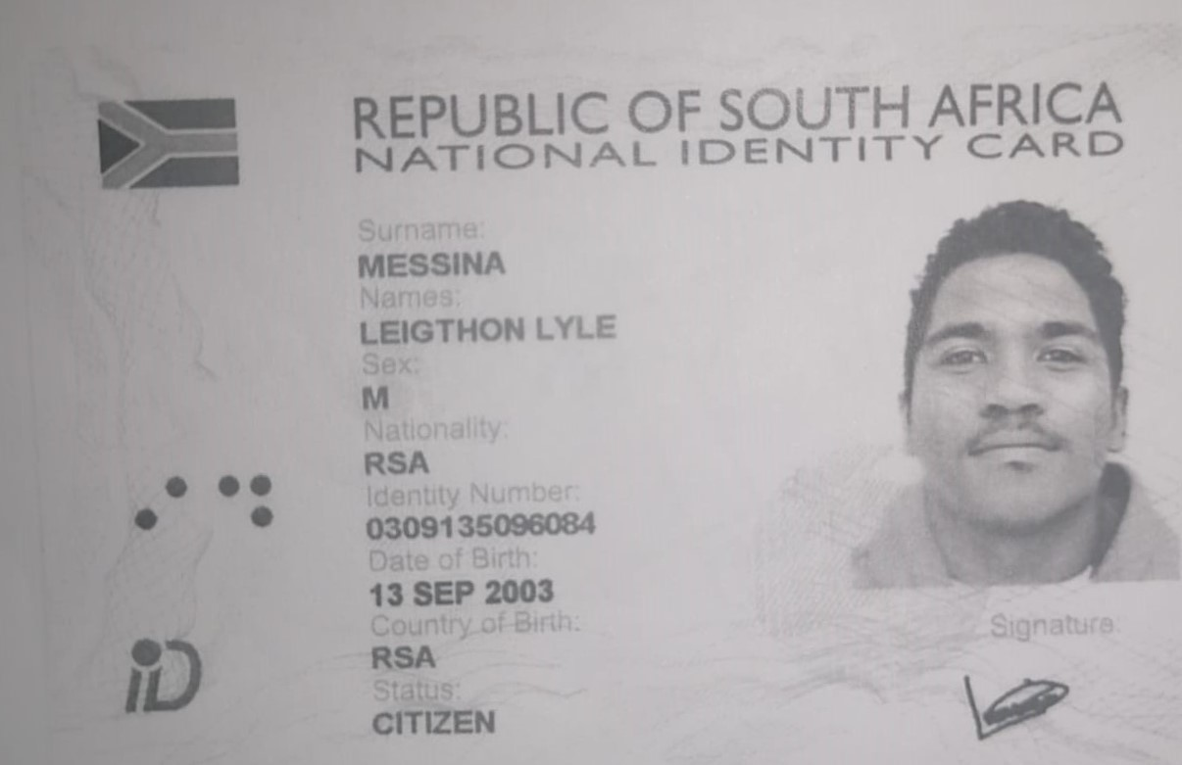 **Identification Document:**

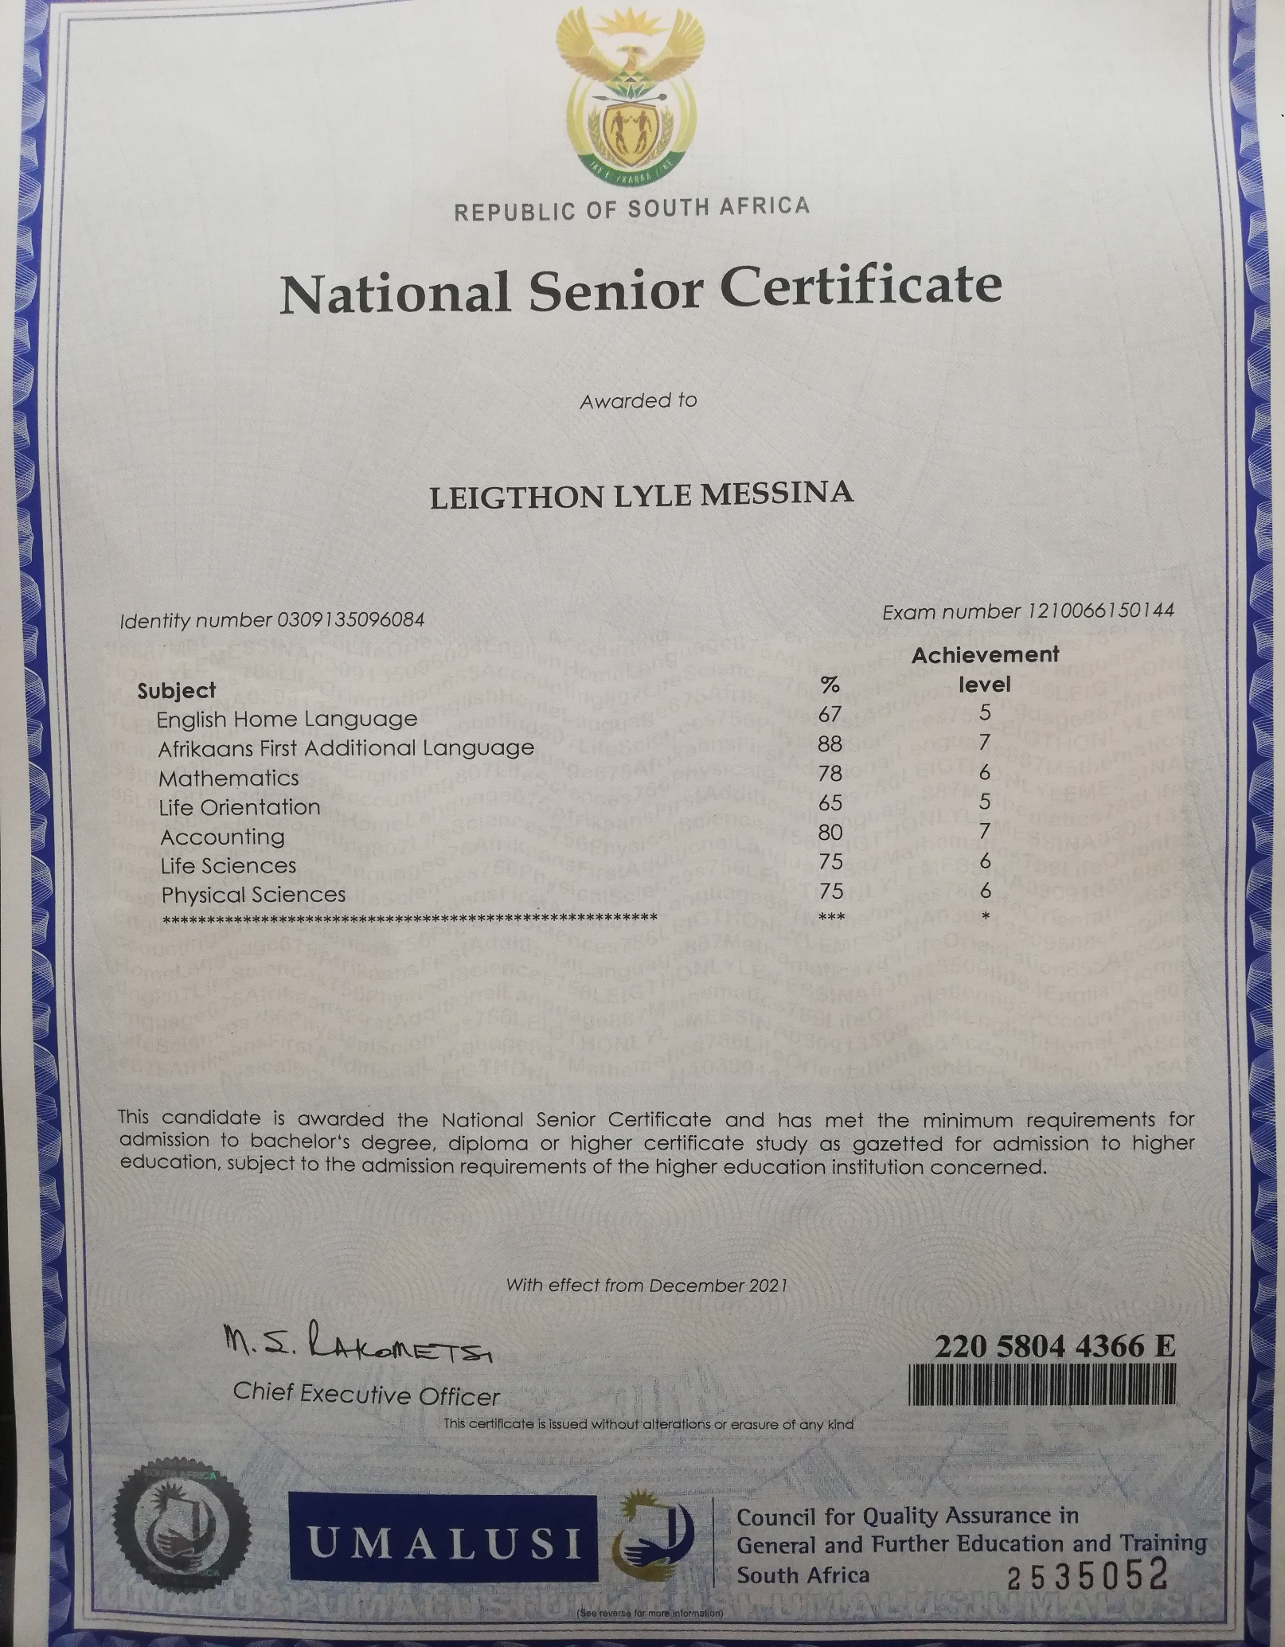 **Matric Certificate:**